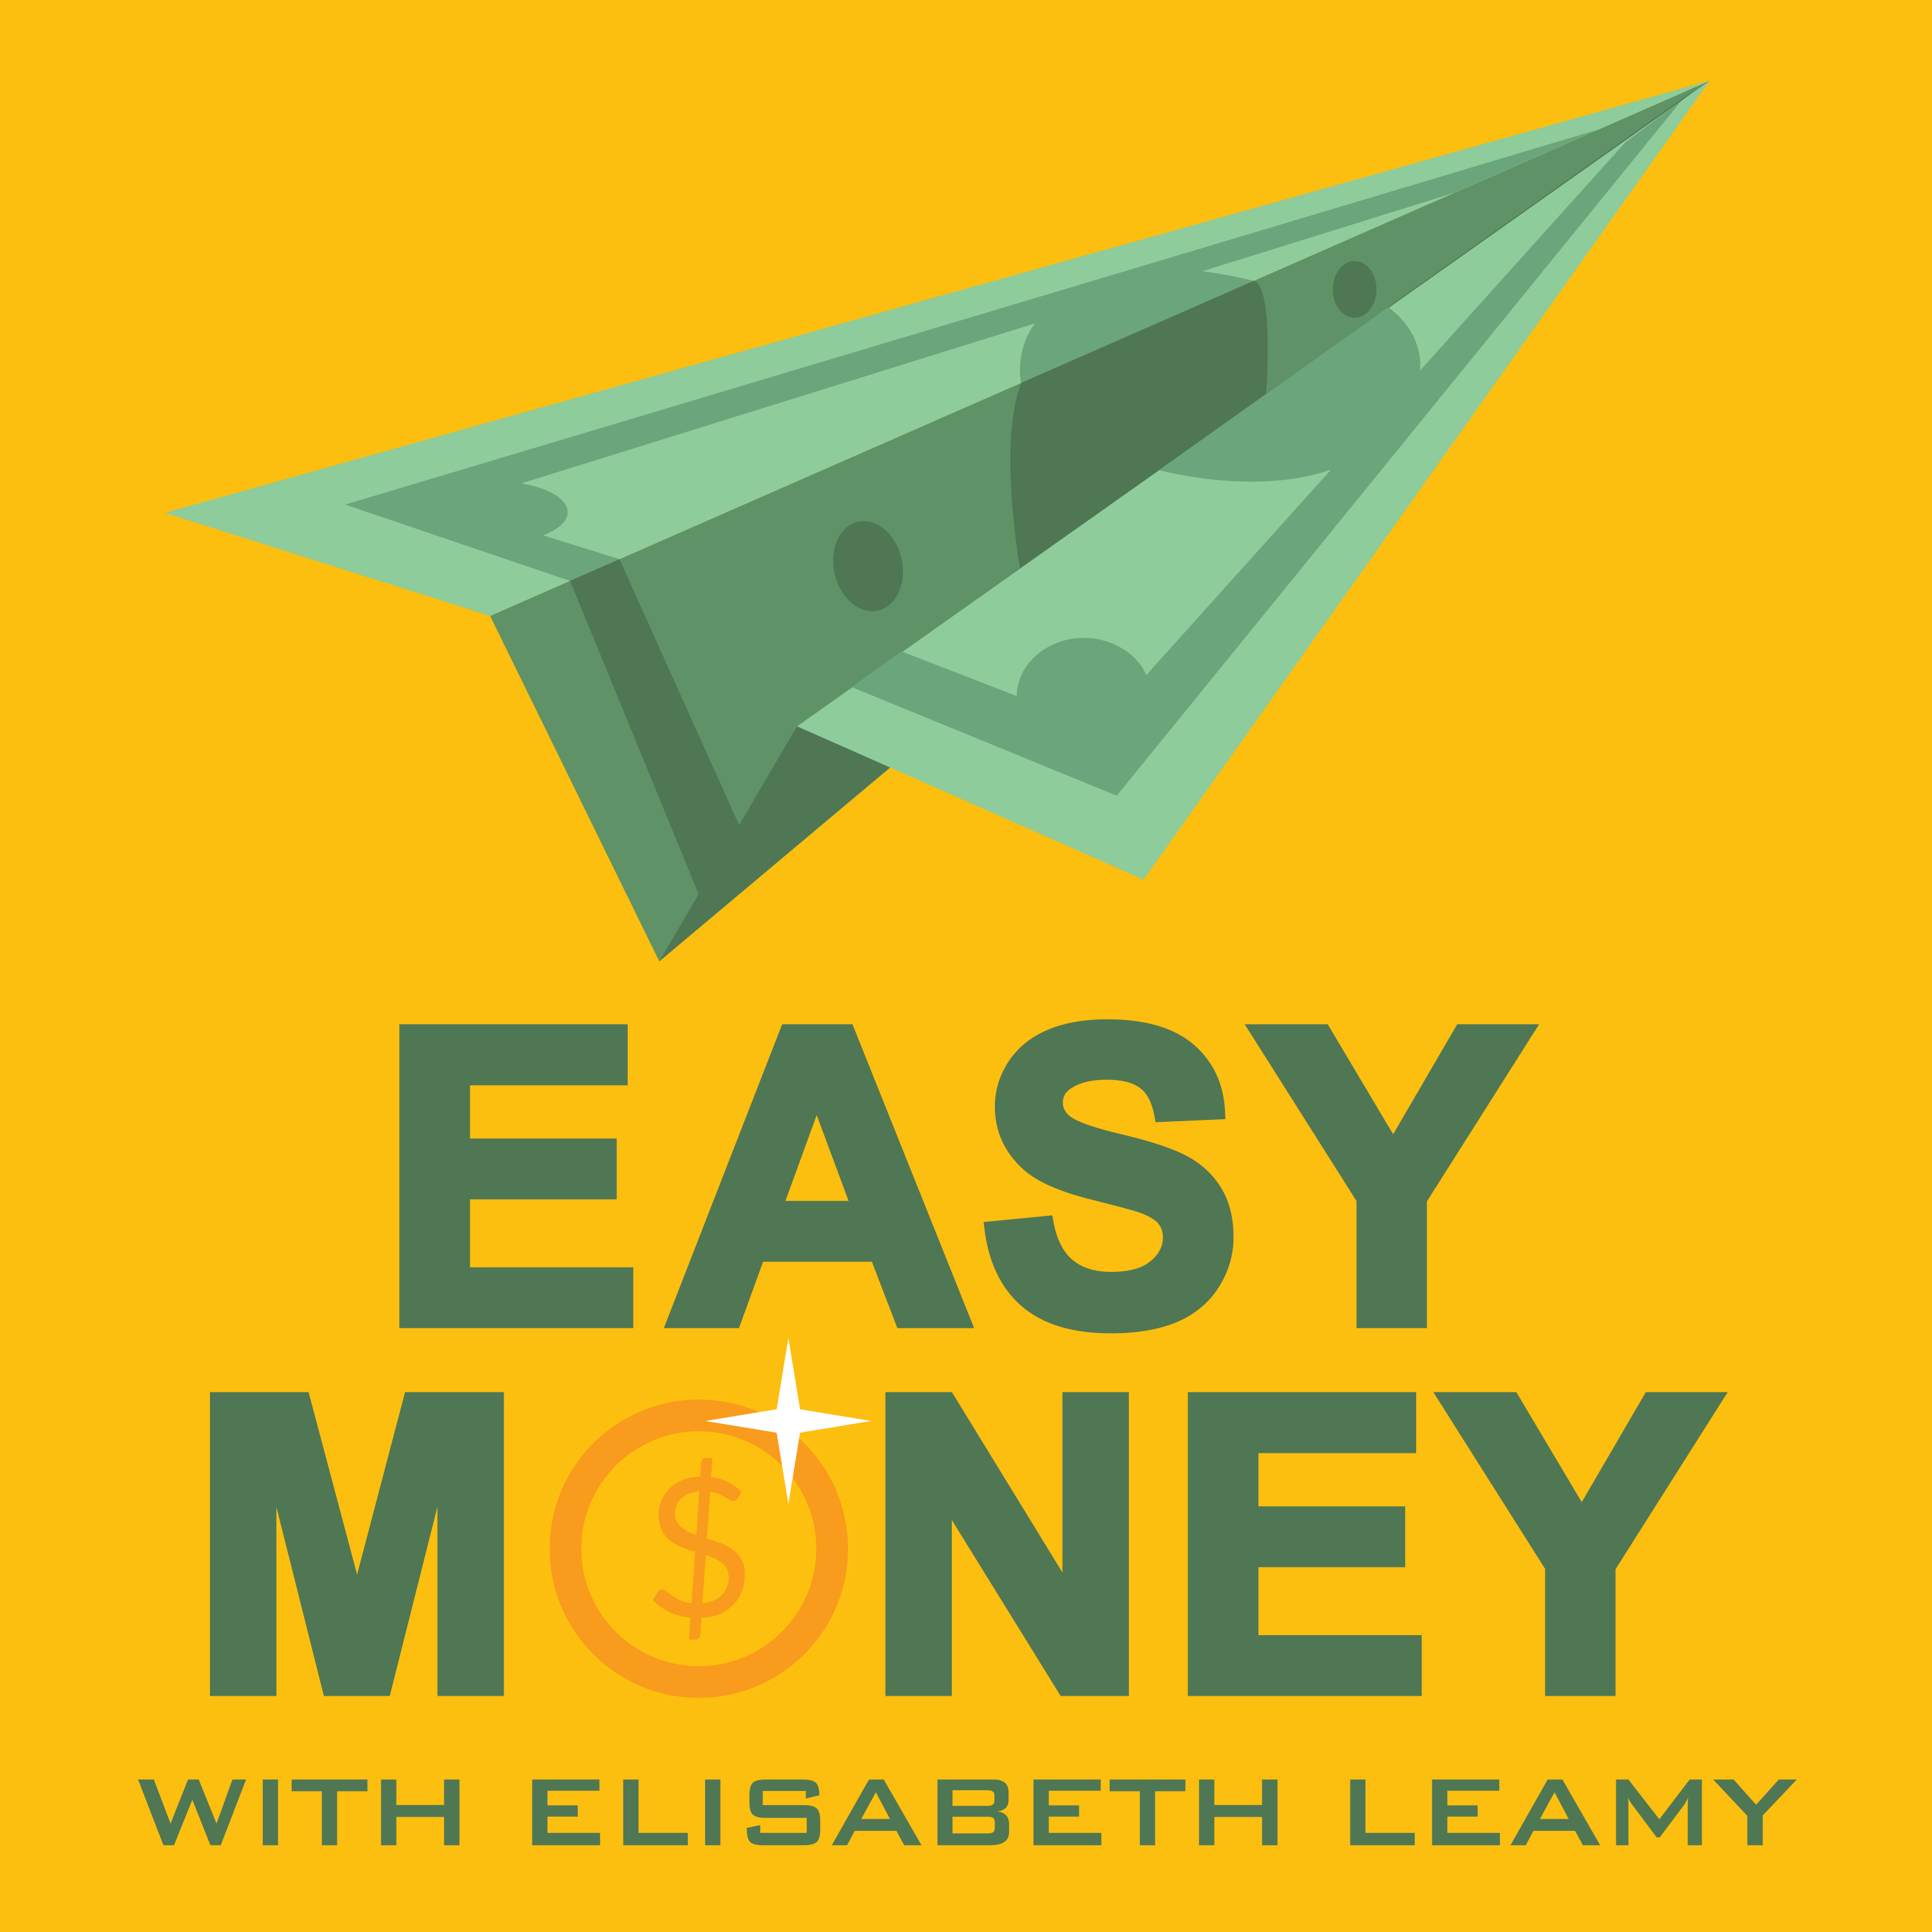

For Immediate Release Contact: Elisabeth Leamy (202) 276-7444
Elisabeth@ElisabethLeamy.com

5 Ways To Save Money —BIG Money, Not Small
Award-winning Print/Broadcast Journalist Elisabeth Leamy Shares Clever, Creative Money-Saving Tips On Her New Podcast “Easy Money”

WASHINGTON, D.C., November, 2017 – People often think small —skipping lattes and brown bagging their lunch —when they try to come up with ways to save money. What if you could significantly cut your spending and save big money instead of small? You can, according to Elisabeth Leamy, Emmy-winning host of the Easy Money podcast. Leamy digs up fresh strategies for saving big money every week, to satisfy an audience looking for answers. She says the key to saving big is to figure out where you spend big. Here’s a hint: Americans’ top five spending categories, according to the Bureau of Labor Statistics, are:

•Housing (rent or mortgage, insurance, maintenance, etc.)
•Vehicles (purchasing, maintaining, insuring, fueling)
•Credit (interest on loans like mortgages, car loans and credit cards.)
•Groceries (food, personal care products, household supplies)
•Healthcare (Insurance premiums, co-pays, prescription meds, etc.)

Those five categories can yield significant savings, but many Americans try to save by taking small steps instead, like skipping lattes, brown bagging lunches or installing low-flow shower heads. Here are several real-life examples of people who were able to save thousands of dollars by focusing on big ticket items instead.

Housing: Fight your property tax assessment. With just a little more legwork than it takes to fight a traffic ticket, you can appeal the property tax assessment on your home. The National Taxpayers Union says 60% of homes are over-assessed. Stu Sendell of Morristown New Jersey appealed, won his case, and is saving $5,309 a year on his property taxes.

Vehicles: Buy a “dark horse” car. By choosing to buy a lesser-known vehicle that is equivalent to one of the most in-demand cars, you can save as much as 20 percent. For example, among luxury compact SUVs, the BMW X3 is the sought-after vehicle and costs nearly $37,500. You can save roughly $7,500 by buying the just-as-good-but-not-as-expensive Acura RDX for about $30,000 instead.

Credit: Ask for “rapid rescoring.” If you’re applying for a mortgage and there’s a mistake on your credit report dragging your credit score down, ask your lender about rapid rescoring. It’s a service carried about by professionals with a direct pipeline to the big three credit bureaus. Valerie Borda of Silver Spring, Maryland saw her score rise from 598 to 690. The higher score netted her a lower interest rate. She will save $72,000 over the life of her loan.

Groceries: Stockpile supplies. We’re taught to separate “needs” from “wants” and only buy groceries when we need them. Here’s a totally different approach: Buy groceries when they’re at their deepest discounts —instead of when you need them— and stockpile them for later! “This strategy is counterintuitive," said Stephanie Nelson of CouponMom.com. Nelson says stockpiling can save you as much as 40 percent on groceries.

Healthcare: Hire a Medical Billing Advocate. 80 percent of hospital bills contain errors, according to Medliminal, a cost containment company. Medical billing advocates find and fight errors on hospital, doctor and insurance bills. Many work on contingency, so you only pay if they find you savings. A medical billing advocate helped Cynthia Kulp of Key West Florida $6,858 after she had surgery for breast cancer. The advocate found multiple, glaring errors and the hospital agreed to cut Kulp’s bill roughy in half.

Leamy devotes a third of each Easy Money podcast to money-saving tips. Some of her latest: refinancing a car loan and getting scholarships for kids’ activities. “I love digging up little-known ways to save large amounts of money,” said Leamy. “Big savings are not hard to pull off. It’s just that people don’t know these strategies.”

About The Easy Money Podcast and Host Elisabeth Leamy:
Every week on Easy Money, 13-Time Emmy-winner Elisabeth Leamy (Washington Post, Good Morning America, Dr. Oz) uncovers clever, creative ways to make more money, save more money and find your unclaimed money. Her goal is to make understanding money easy —not hard. By utilizing this story idea, you will be getting quality FREE content, while helping an ad-free, educational podcast. Download all story materials at: EasyMoneyShow.com/press-kit.

Easy Money Podcast Links: (Please include these links on your website in exchange for use)
Easy Money on iTunes: http://apple.co/2tpUY6v
The Easy Money Show website: EasyMoneyShow.com

##

TAGS: Ways to Save Money, Money saving tips, how to save money, save money, Easy Money

